Alpha testing report:

Testing Scope:

* Login Page
* Register as a user
* Register as an association
* Admin home page
* User home page
* Association home page

1. Login Page:

We have considered the following test cases(test cases are in bold and have a hollow bullet):

* **Null Input:** Giving null inputs to any of the fields or all the fields throws error as expected.
* **Invalid Input (wrong user id and password):** Giving invalid credentials throws popup error stating “Please enter valid username and password” as expected.
* **Correct input for User:** Giving correct credentials for user type account redirects to user homepage as expected.
* **Correct input for approved Association:** Giving correct credentials for an already approved association type account redirects to association homepage as expected.
* **Correct input for unapproved Association:** Giving correct credentials for an unapproved association type account throws popup error stating ”Pending Approval” as expected.
* **Correct input for Admin:** Giving correct credentials for admin type account redirects to admin homepage as expected.
* **Exiting the application:** Exits the application and closes all the jFrame’s.

1. Register as a user:

We have considered the following test cases(test cases are in bold and have a hollow bullet):

* **Null Input:** Giving null inputs to any of the fields or all the fields throws error as expected.
* **Different inputs for verify password and password:** Highlights the password fields in red as expected.
* **Giving an already existing user name:** Throws invalid error popup as expected.
* **Invalid characters input:** Giving special characters as inputs does not throw an error as expected. So now assuming user has been created, when we try to login it throws error.
* **Back button testing:** Clicking the back button takes us back to login page as expected.
* **Checking if the data is saved if we revisit this page:** Clicking the back button after entering some data in the textfields and then coming back to this registration page reset all the fields as expected.
* **Exiting the application:** Exits the application and closes all the jFrame’s.

1. Register as an Association:

We have considered the following test cases(test cases are in bold and have a hollow bullet):

* **Null Input:** Giving null inputs to any of the fields or all the fields throws error as expected.
* **Different inputs for verify password and password:** Highlights the password fields in red as expected.
* **Giving an already existing user name:** Throws invalid error popup as expected.
* **Invalid characters input:** Giving special characters as inputs does not throw an error as expected. So now assuming user has been created, when we try to login it throws error.
* **Back button testing:** Clicking the back button takes us back to login page as expected.
* **Checking if the data is saved if we revisit this page:** Clicking the back button after entering some data in the textfields and then coming back to this registration page reset all the fields as expected.
* **Exiting the application:** Exits the application and closes all the jFrame’s.

Note: This is same as the Register as a user page testing as they are almost similar and have the same validation. The difference between them boils down to some extra field for associations.

1. User home page:

We have considered the following test cases (test cases are in bold and have a hollow bullet):

* **Testing by clicking on the following buttons:**
* **Profile:** Navigates to the profile panel as expected.
* **Home:** Navigates to the home panel as expected.
* **Upcoming Events:** Navigates to the upcoming events panel as expected.
* **Past Events:** Navigates to the past events panel as expected.
* **My Associations:** Navigates to my associations panel as expected.
* **Explore Associations:** Navigates to the explore associations panel as expected.
* **Explore Events:** Navigates to the explore events panel as expected.
* **Logout:** Logs the user out and returns back to the login page.

For pages we have performed the following testing with different settings, they are:

* **Testing Initially:**

Initial testing when the user is newly created and it follows no event or association. The pages are then affected as follows:

* **Profile:** All user information was correctly displayed.
* **Home:** initially the home page was empty as expected.
* **Upcoming Events:** Initially was empty as expected.
* **Past Events:** initially was empty as expected.
* **My Associations:** initially was empty as expected.
* **Explore Associations:** All the associations registered and approved by the admin were displayed as expected.
* **Explore Events:** All the events which are going to take place in the next five days were displayed as expected.
* **Testing after following events:** *Gives popup “Followed the event: eventName”*

Clicking the follow button for one or more events changes the following pages:

* **Home:** If the home page contained the followed event before then it now disappears from this page as expected.
* **Upcoming Events:** Gets updated to reflect the followed event as expected.
* **Explore Events:** All the events which are going to take place in the next five days were displayed as expected. The said event which we followed is not displayed here as expected.
* **Testing after following associations:** *Gives popup “Followed the association: associationName”*

Clicking the follow button for one or more associations changes the following pages:

* **Home:** Gets updated to show the upcoming events from the association we just followed as expected.
* **My Associations:** Gets updated to reflect the followed association as expected.
* **Explore Associations:** All the associations registered and approved by the admin were displayed as expected. The said association we followed disappears from this table as expected.
* **Testing after unfollowing followed events:** *Gives popup “Unfollowed the event: eventName”*

Clicking the unfollow button for one or more event changes the following pages:

* **Home:** If the event we unfollowed belongs to an association we follow: home updates to display the unfollowed event as expected.
* **Upcoming Events:** Gets updated to remove the unfollowed event as expected.
* **Explore Events:** All the events which are going to take place in the next five days were displayed as expected. The said event which we unfollowed is also displayed here as expected.
* **Testing after unfollowing followed associations:** *Gives popup “Unfollowed the association: associationName”*

Clicking the unfollow button for one or more associations changes the following pages:

* **Home:** Updated to remove the events by the unfollowed association as expected.
* **My Associations:** Updated to remove the unfollowed association as expected.
* **Explore Associations:** Update to also include the unfollowed association as expeted.

1. Association home page:

We have considered the following test cases (test cases are in bold and have a hollow bullet):

* **Testing by clicking on the following buttons:**
* **Profile:** Navigates to the profile panel as expected.
* **Upcoming Events:** Navigates to the upcoming events panel as expected.
* **Past Events:** Navigates to the past events panel as expected.
* **Create an Event:** Navigates to the create an event panel as expected.
* **Logout:** Logs the user out and returns back to the login page.

For pages we have performed the following testing with different settings, they are:

* **Testing Initially:**

Initial testing when the association is newly created and approved. The pages are then affected as follows:

* **Profile:** All user information was correctly displayed.
* **Upcoming Events:** Initially was empty as expected.
* **Past Events:** initially was empty as expected.
* **Create an Event:** Displays a form to create an event as expected.
* **Testing after creating an event:** *Gives popup “Successfully created an event!”*
  + **Validations in the create an event form:** Giving null inputs for required fields highlights the textfields to red color. Also, in the start and end dates only dates after the current sysdate are enabled.

Creating one or more events changes the following pages:

* **Upcoming Events:** Updates to show the newly created event as expected.
* **The new event is visible to users:** The newly created event is visible to users under the home or explore events panel.

1. Admin home page:

We have considered the following test cases:

We have considered the following test cases (test cases are in bold and have a hollow bullet):

* **Testing by clicking on the following buttons:**
* **Profile:** Navigates to the profile panel as expected.
* **Home:** Navigates to the home panel as expected.
* **Logout:** Logs the user out and returns back to the login page.

For pages we have performed the following testing with different settings, they are:

* **Testing when we login:**
* **Profile:** All user information was correctly displayed.
* **Home:** Displays all pending approvals as expected.
* **Testing after approving an association:** *Gives popup “Approved associationName”*
  + **Home page:** The approved association is no longer visible in this home page.
  + **Logging in as the association:** We are now able to log in as the association.
* **Testing after rejecting an association:** *Gives popup “Rejected associationName”*
  + **Home page:** The rejected association is no longer visible in this home page.
  + **Logging in as the association:** Throws error popup stating invalid username and password.

Final Statistics:

Total number of test cases performed per module:

|  |  |  |  |
| --- | --- | --- | --- |
| **Module** | **Tests** | **Successful Tests** | **Failed Tests** |
| Login Page | 7 | 7 | 0 |
| Register as a user | 7 | 6 | 1 |
| Register as an association | 7 | 6 | 1 |
| Admin home page | 13 | 13 | 0 |
| User home page | 7 | 7 | 0 |
| Association home page | 6 | 5 | 1 |
| TOTAL | 47 | 44 | 3 |

Attaching screenshots for all of the above-mentioned testing is not feasible so, we have attach screenshots for the most important test cases below:

**Login Page:**

* Null Input:

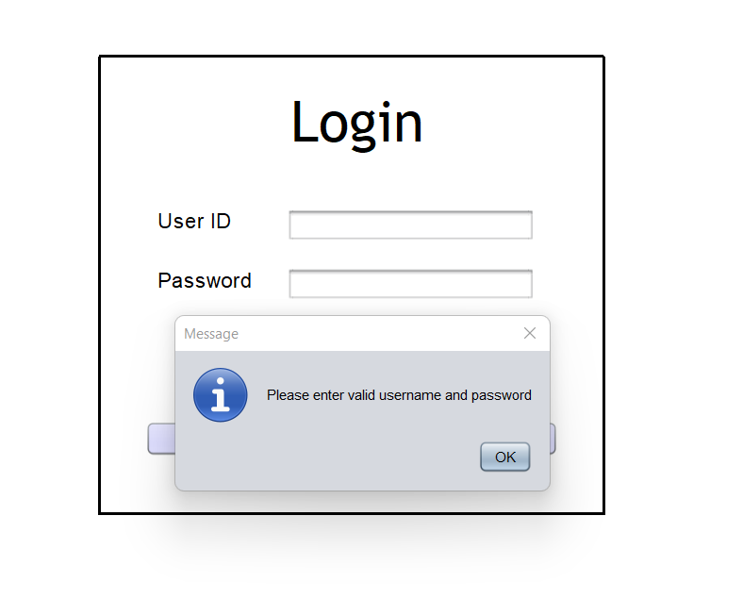

* Invalid Input:

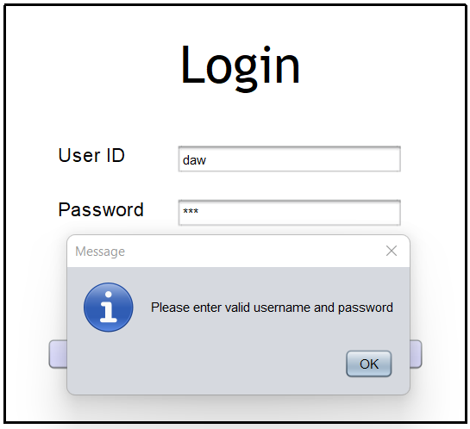

* Pending approval for association user:

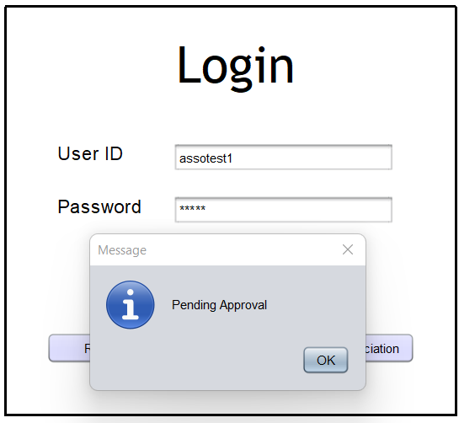

**Register as User:**

* Null Input:

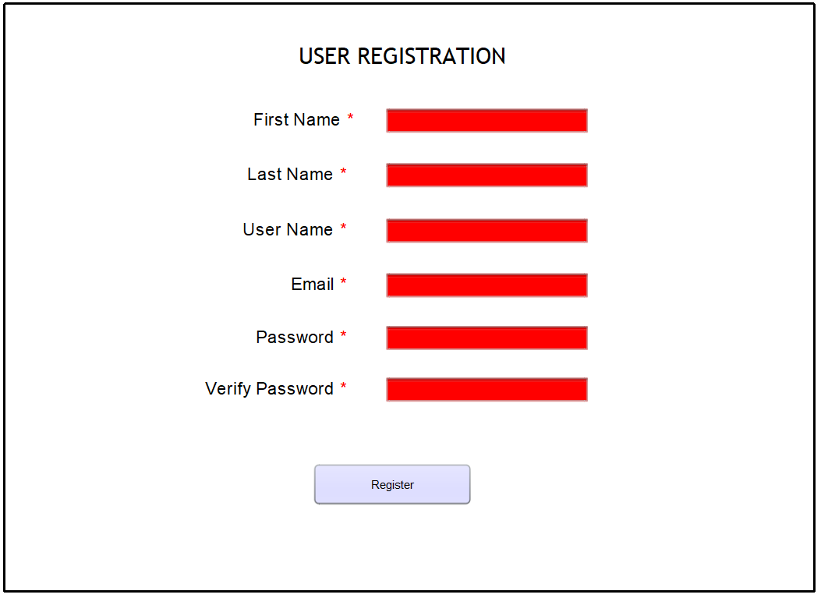

Mismatching password and verify password:

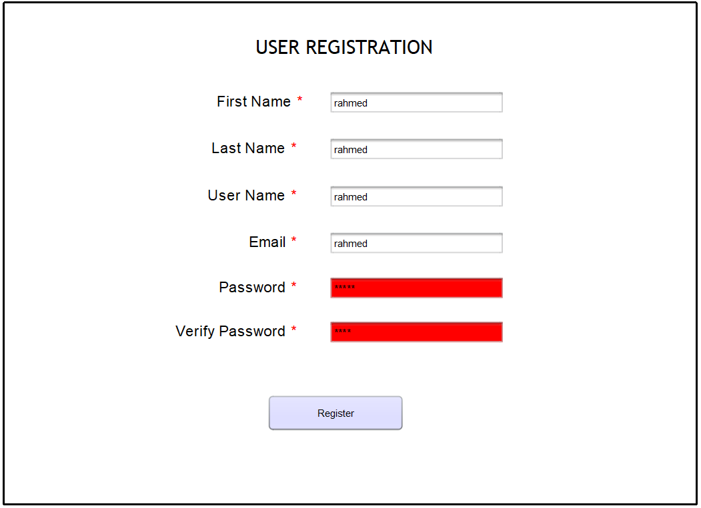

Already existing User:

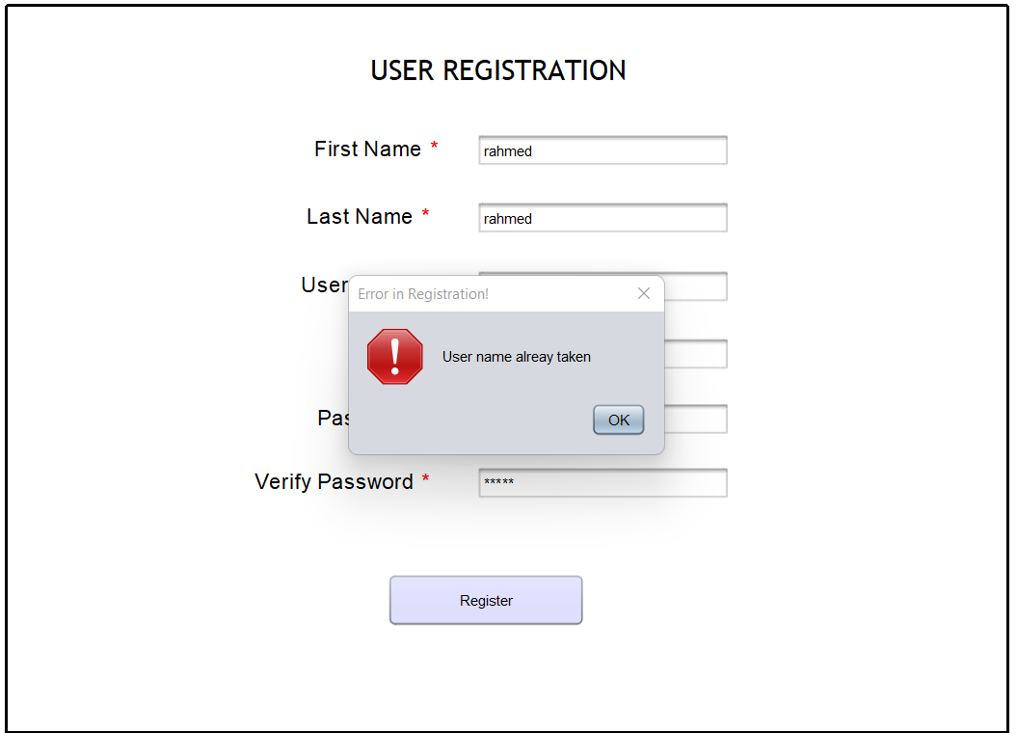

**Register as an Association:**

* Null Input:

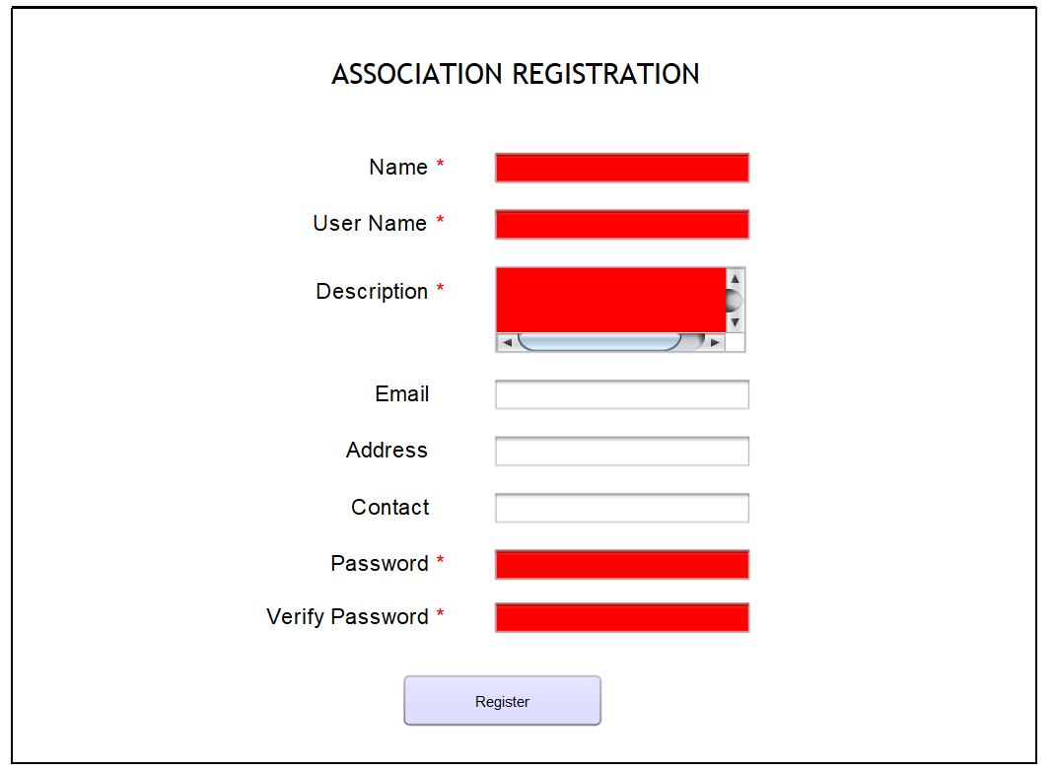

Mismatching password and verify password:

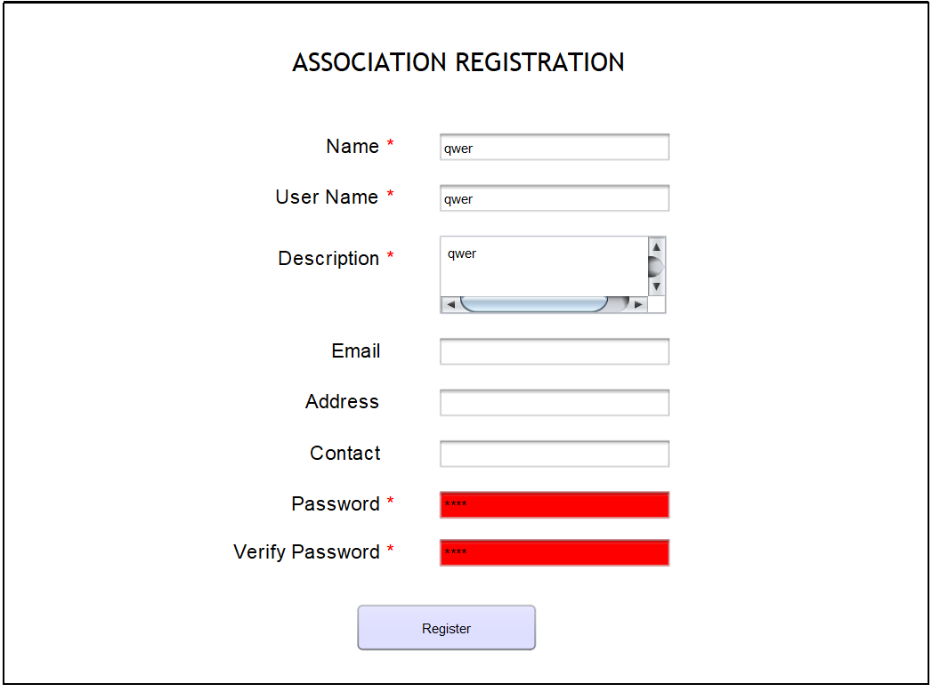

Already existing username:

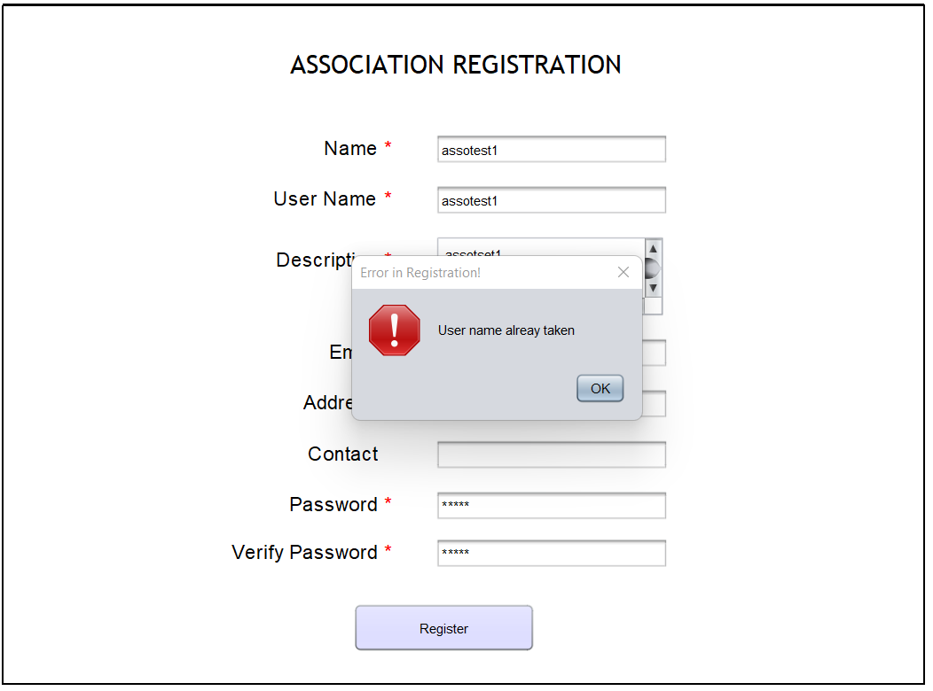

**Admin Page:**

* Home page:

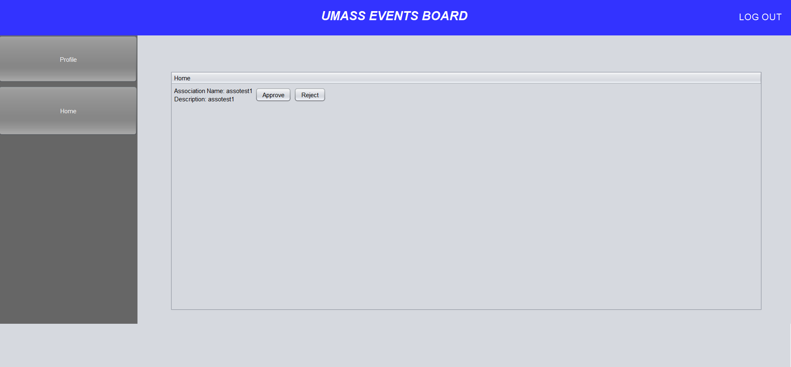

Rejecting an association:

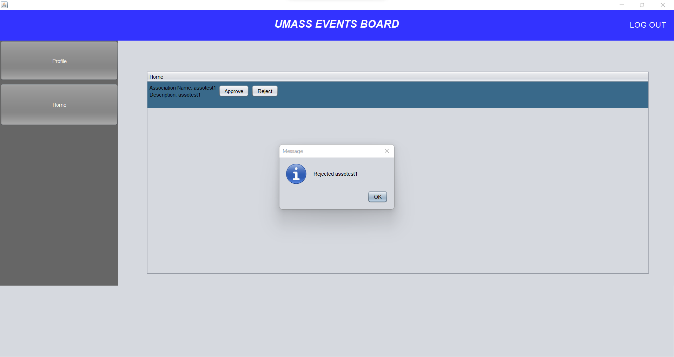

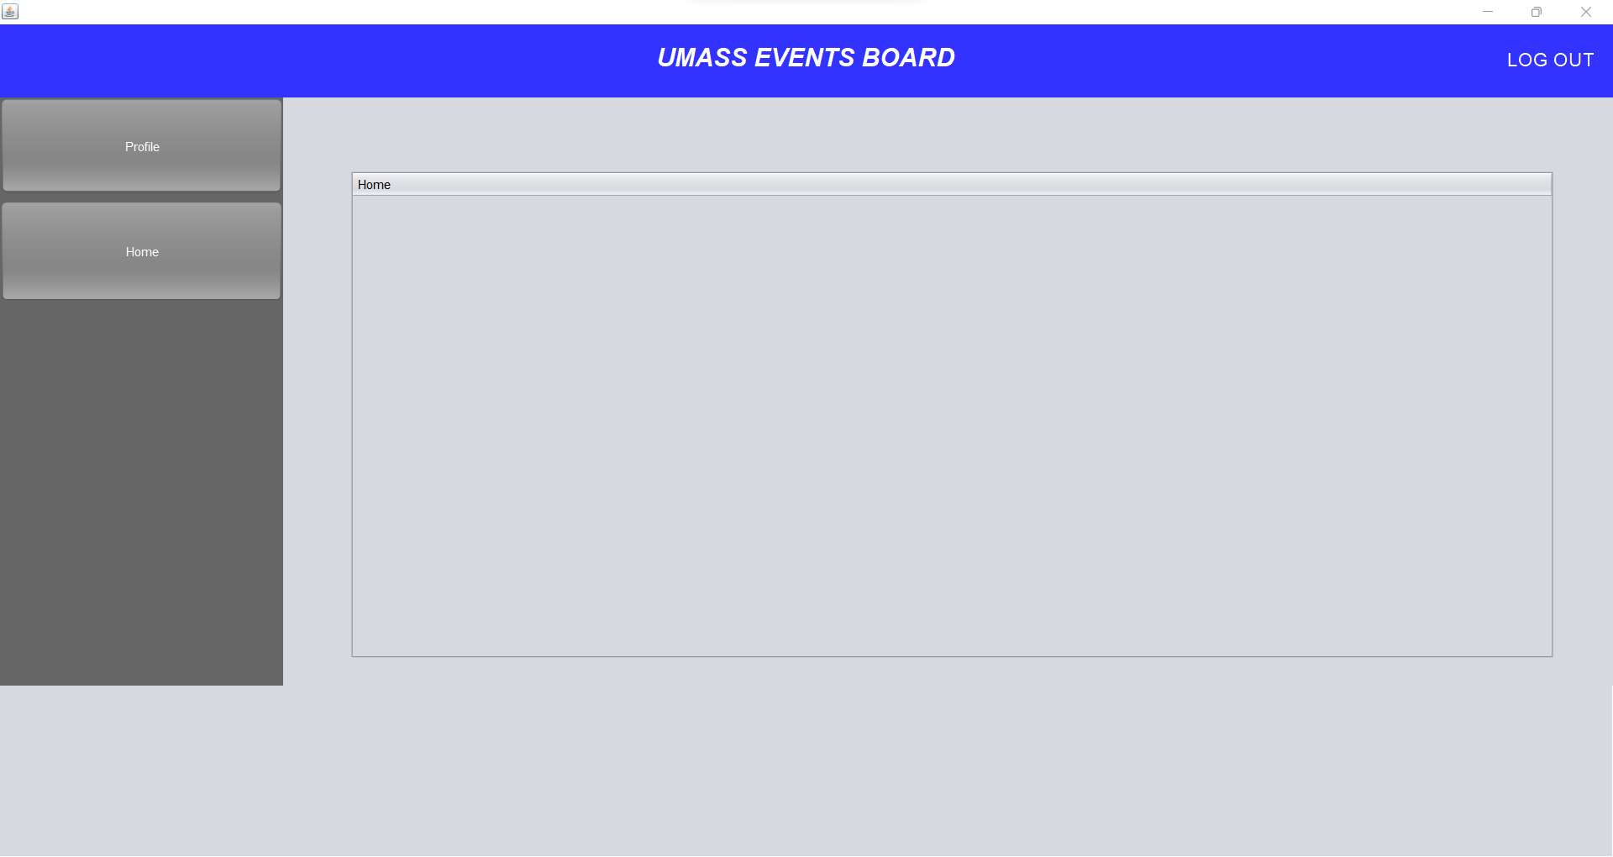

Association Home page:

* Initial:

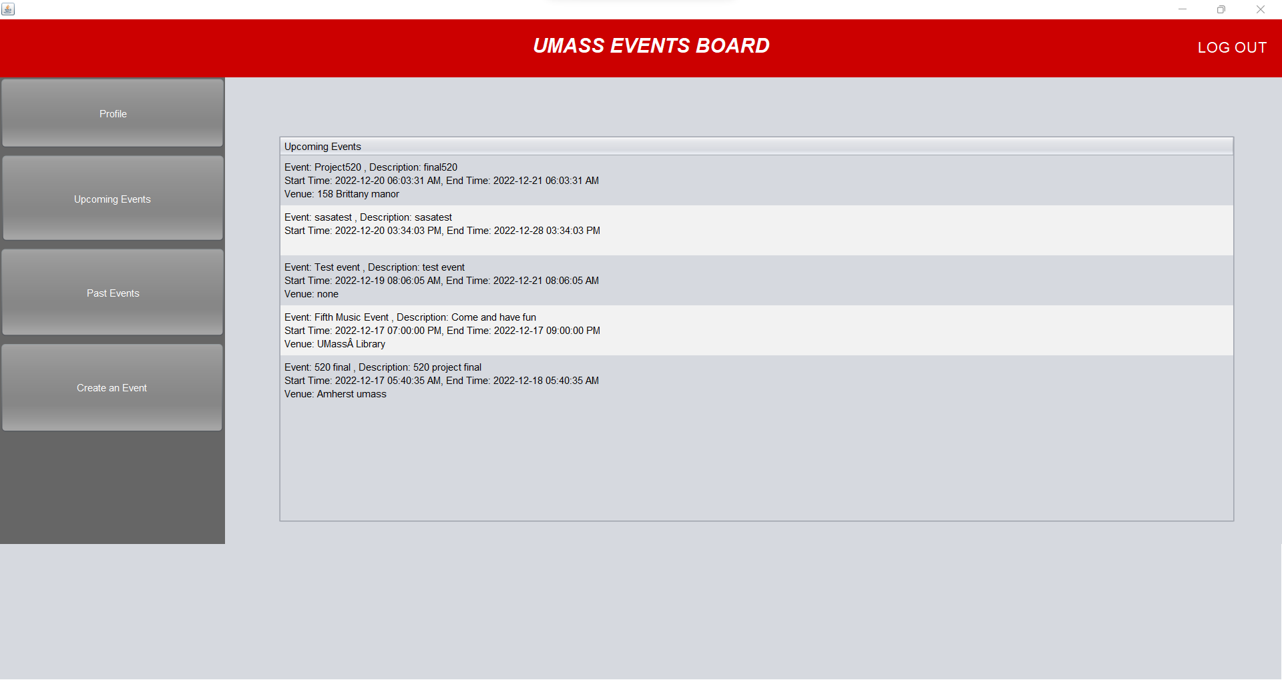

Create an event null input:

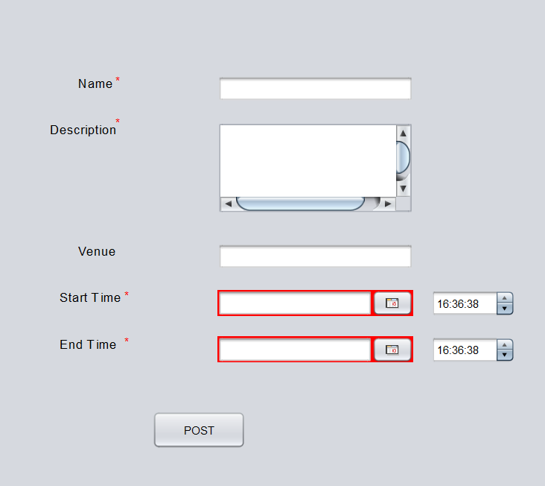

Create an event older date disabled:

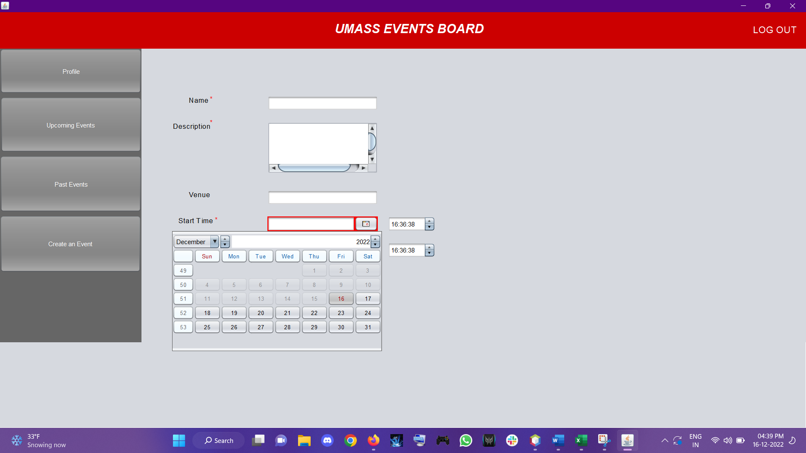

Creating a new event successfully:

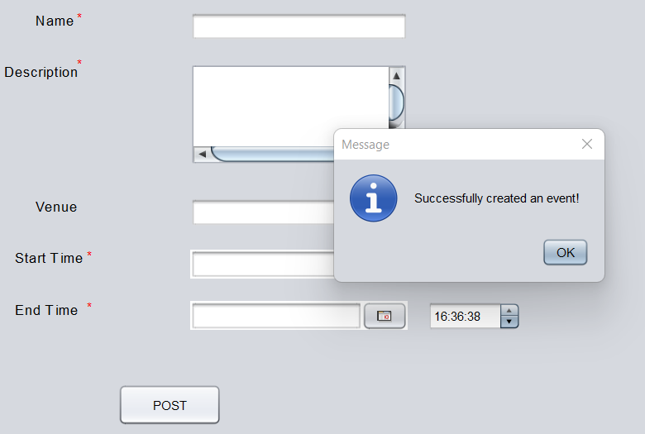

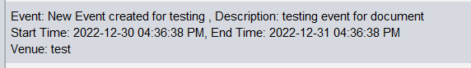

**User Home page:**

* Initial:

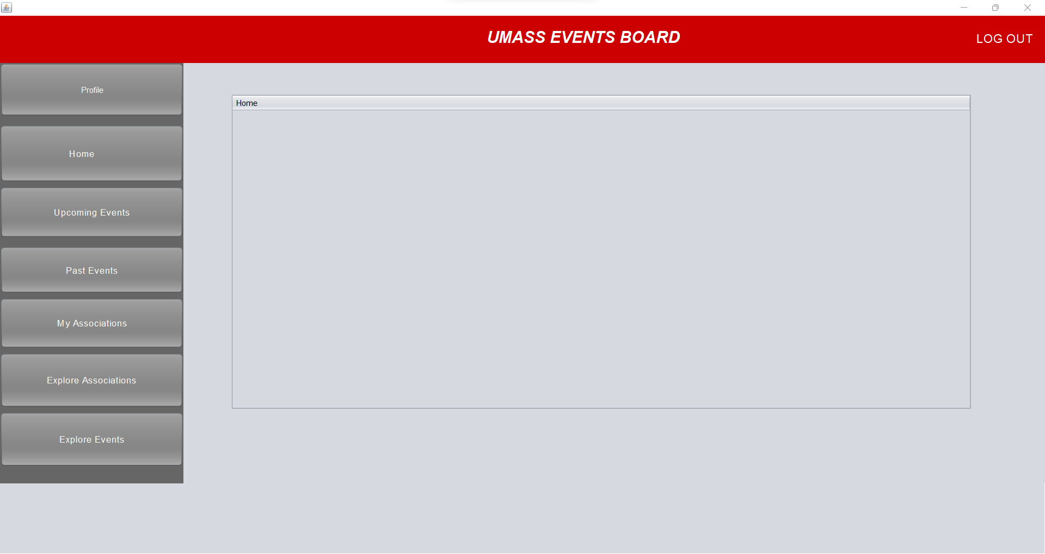

Following an event:

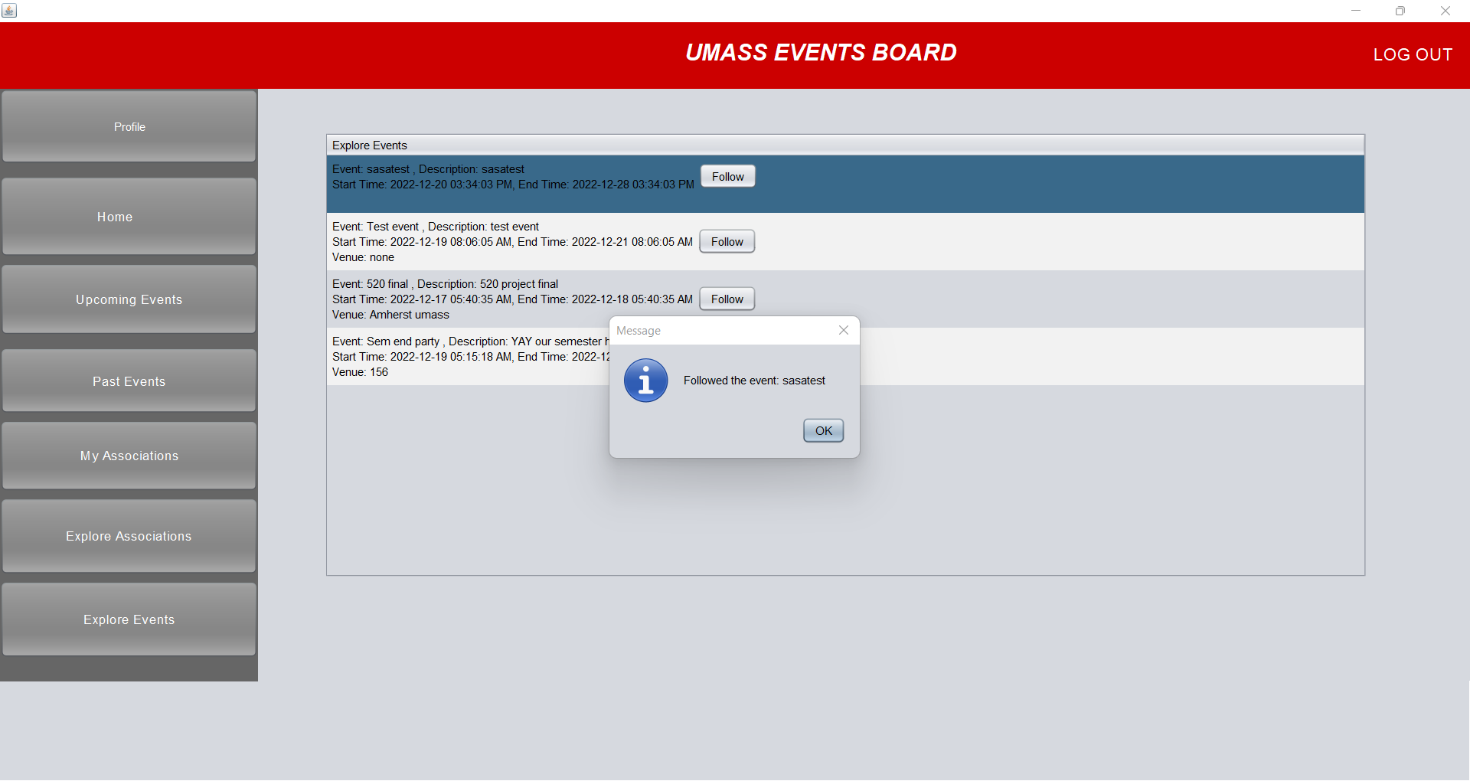

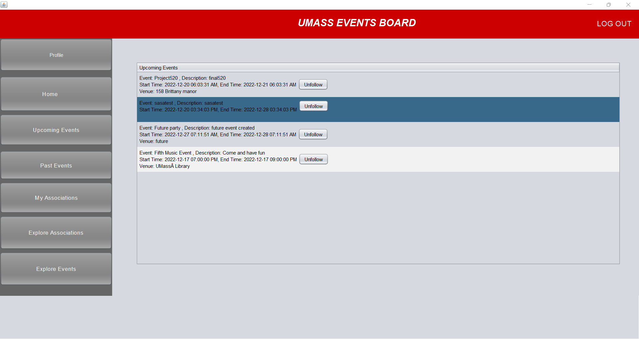

Following an association:

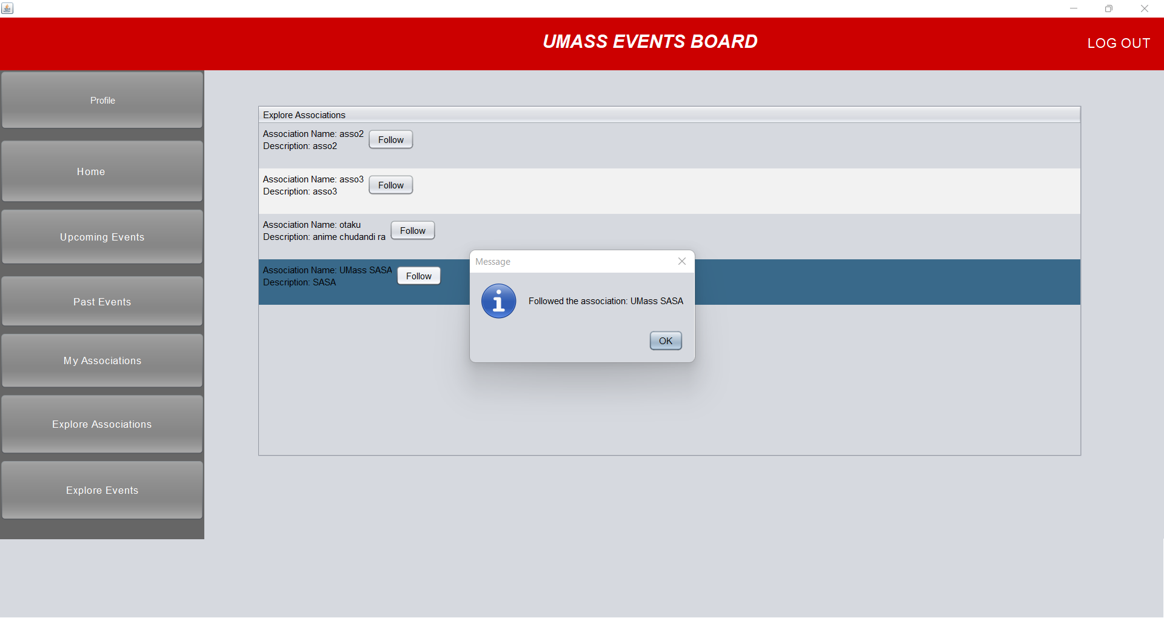

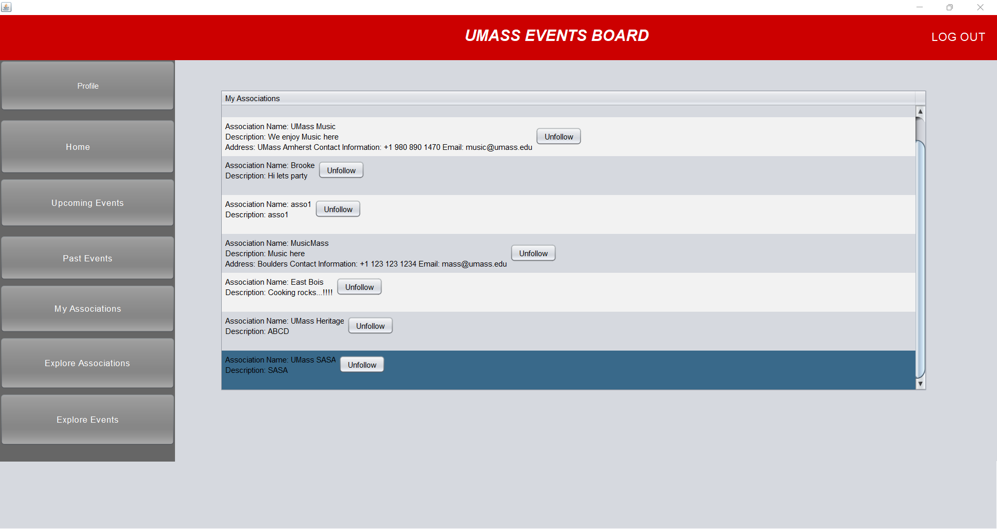

Unfollowing an event:

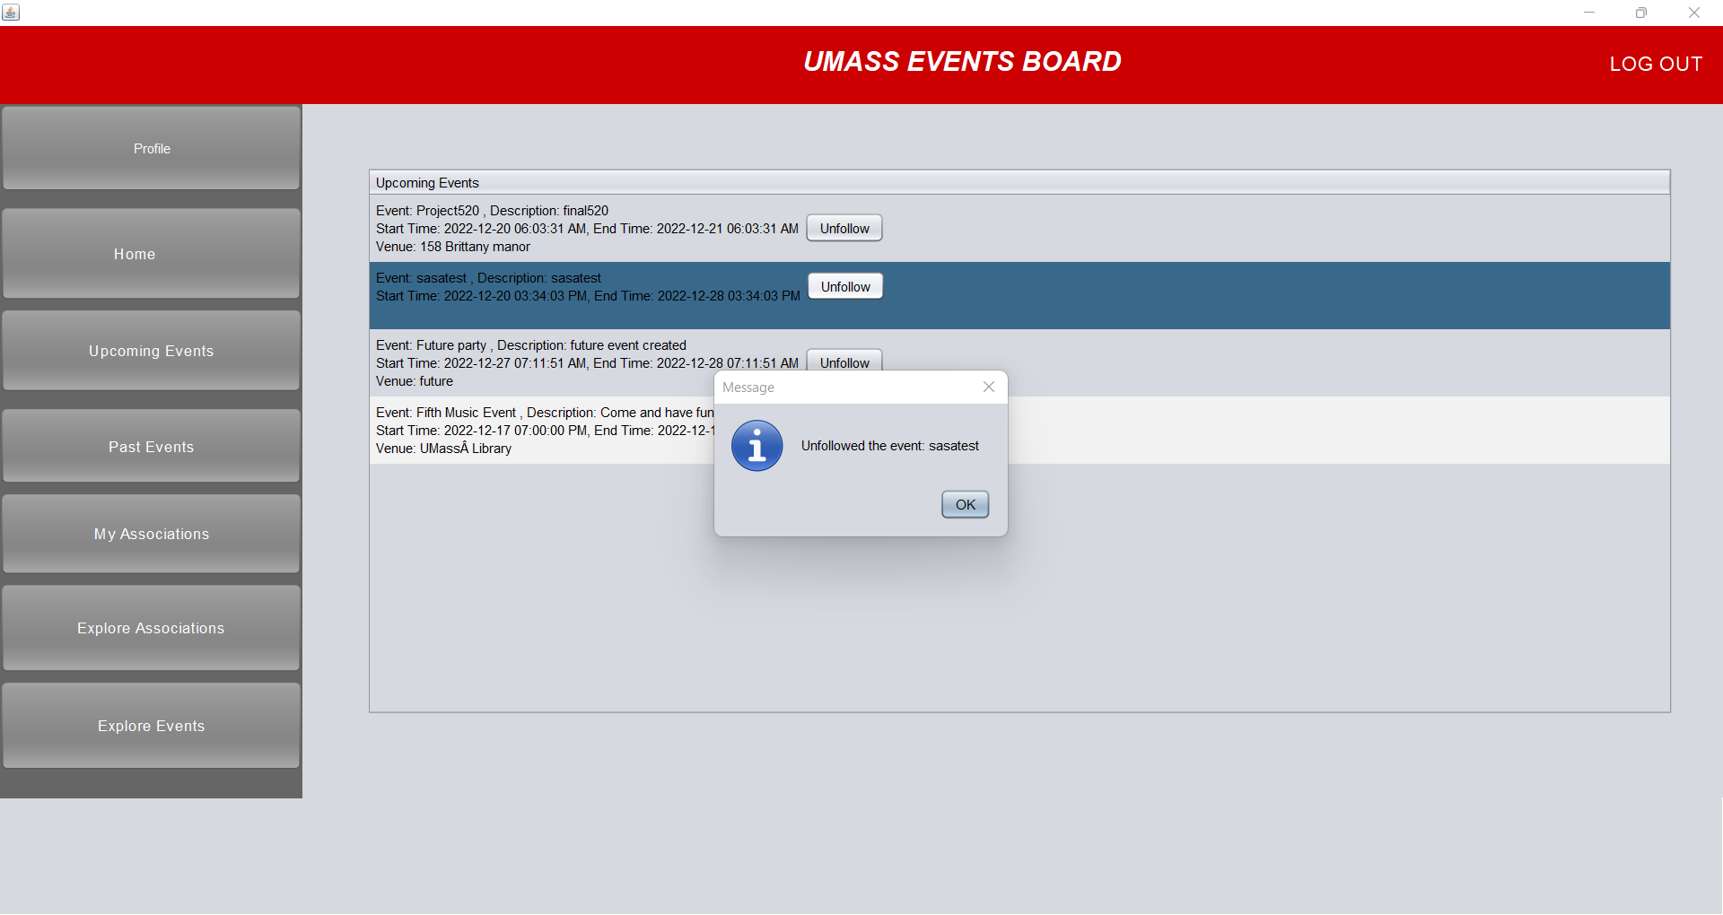

Unfollowing an association:

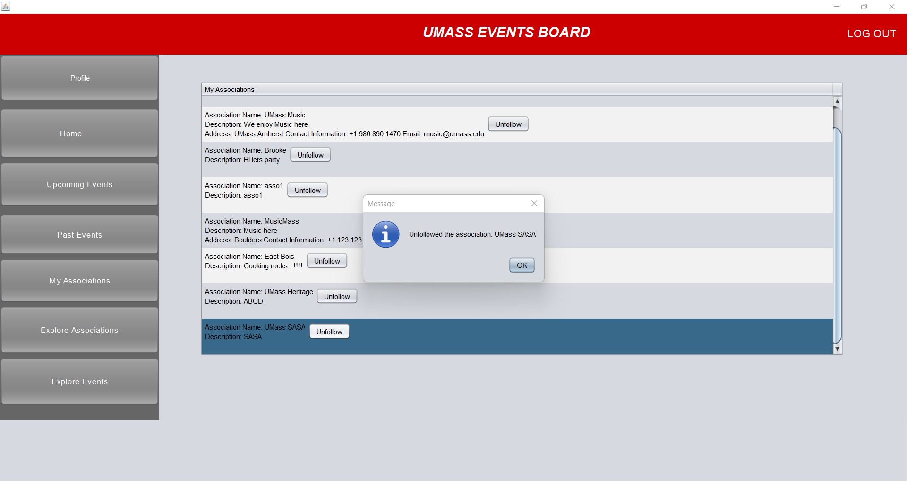

Profile panel:

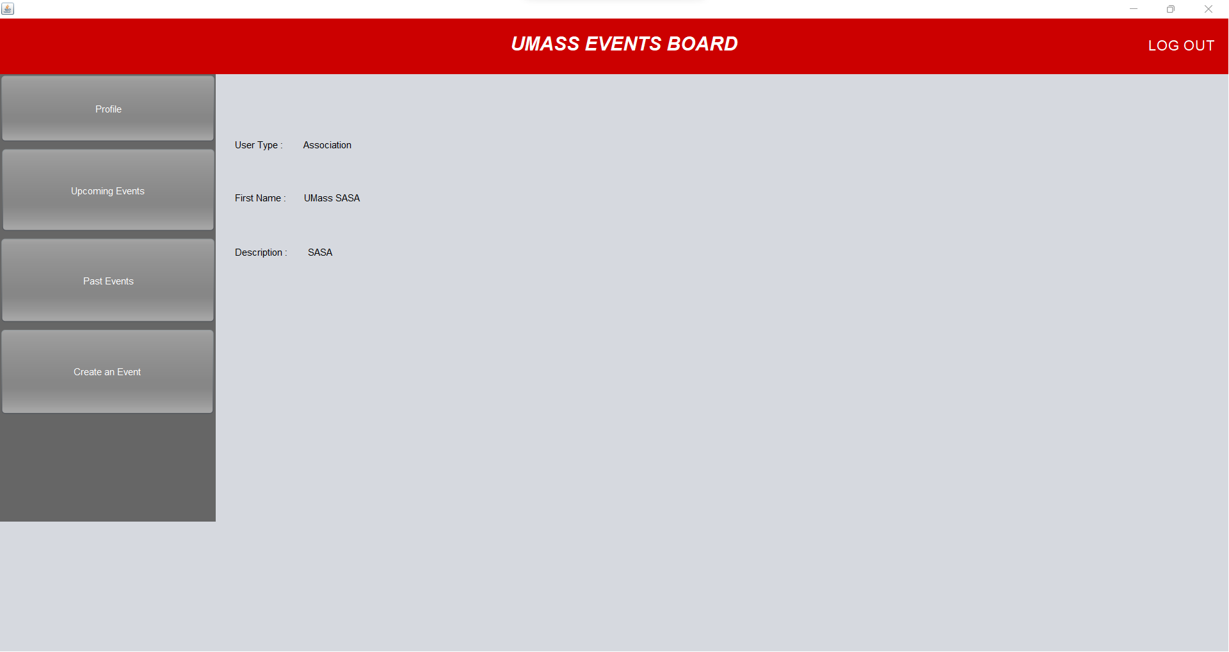

Explore association panel:

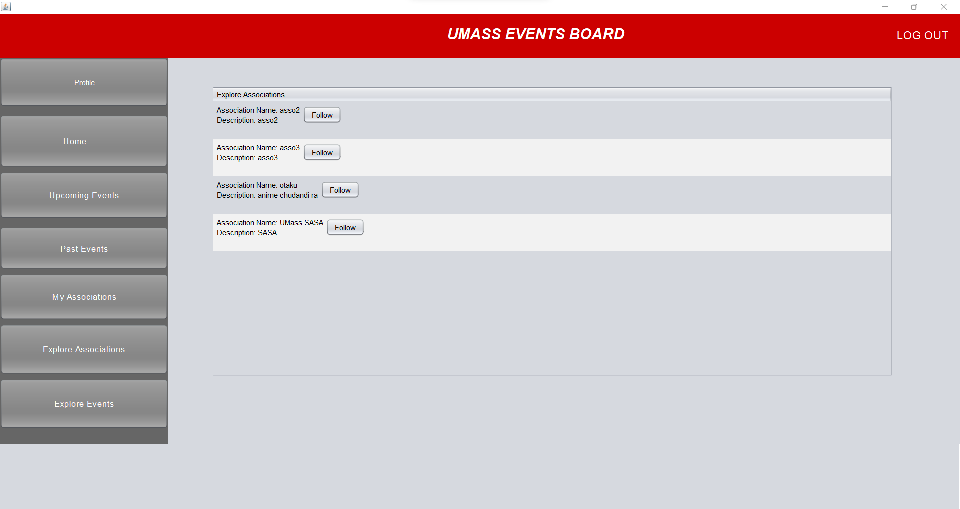

Explore events panel:

